

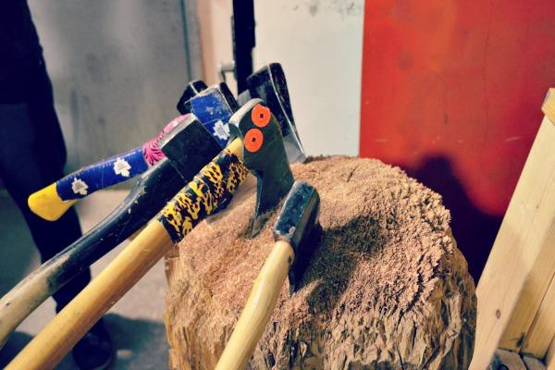
On June 16th please come out and support
Send a Kid to Camp Axe-Travaganza
Throw an axe and send a kid to camp!
Tickets only $35
Call 705-743-9751 ex1317 to sign up.

Send a Kid to Camp

Axe-Travaganza

June 16, 2017

7 - 10pm

Located At:

20 Perry Street

Peterborough, ON

